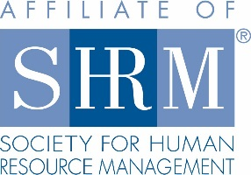
2018 Rocky Mountain Case Competition
Key Dates and Deadlines Timeline

Event Date: March 23rd – March 24th
Event Location: Colorado State University: Fort Collins, Colorado

Date | Deadline/Action Item | Notes
By February 28th | Request case scenario from SHRM | Case will be only be provided for state-wide events, and no earlier than 21-days prior to event
February 16th | Early Team Registration deadline | All team captains will receive a registration confirmation, as well as all team-related competition documents
February 23rd | Late Team Registration deadline | All team captains will receive a registration confirmation, as well as all team-related competition documents
March 1st | Volunteer Registration deadline  (NCHRA & CSU SHRM Members) | Can be extended if more volunteers needed
March 8th | Confirm receipt of signed Integrity Statement from team captains | Integrity Statements will be sent to team captains March 5th and are expected to be signed and returned by this date
March 9th | Provide case scenario (team version) to registered team captains | Provide teams with 7 days to review case and develop PPT presentation
March 12th | Provide case scenario (judge’s version) to volunteer judges | Provide judges with at least 10 days to review case in preparation for onsite role
March 16th | PPT presentations and other documents are DUE BY: 5PM | Team captains will receive information to whom and how to submit all relevant documents

