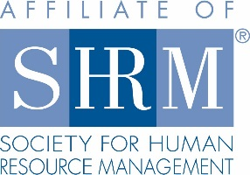
2018 Rocky Mountain Case Competition
Integrity Statement

It is the State Council’s intention to provide a fair and unbiased administration of the SHRM State Student Case Competition. To maintain the highest level of integrity throughout the competition, all team participants and faculty advisors must agree to abide by the official Case Competition Rules and Regulations and Codes of Sportsmanship (for case competition team members and faculty advisors.)

I acknowledge that as Team Captain, I will ensure the following:

- The team reads and abides by the official Case Competition rules and Code of Sportsmanship for Case Competition Team Members.
- Our faculty advisor(s) reads and is aware of the official Case Competition rules and the Code of Sportsmanship for Faculty Advisors.
- Work on the case assignment will be completed by the team only.
- The team does not secure advice from advisors, professors, parents, friends, or other personal contacts.
- The team will refrain from sharing information regarding the case, including the proposed solution, in any form prior to, during or following the event.

By signing below, you as the Team Captain:

- Attest that each member of your team competing in the SHRM State Student Case Competition, as well as the team’s faculty advisor, will familiarize themselves with both the official rules and regulations governing the competition and the Codes of Sportsmanship.
- Confirm acknowledgement of, and agreement with, the following principle:

“Any individual determined to be in violation of any official competition rule agrees to abide by the consequences established for violating the competition rule(s), up to and including being disqualified from the competition. Action taken will be at the judgment of the Case Competition Management Team, following appropriate inquiry and/or investigation resulting from a complaint about violating the rules or Codes of Sportsmanship. All decisions are final.”

Signature _____________________________________________

Date________________

Send signed Integrity Statement to Dani Kimlinger at dckimlinger@minesandassociates.com. (Only AFTER Dani receives this statement from your team will she be permitted to provide you with the case.)

