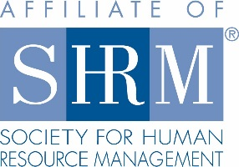
2018 Rocky Mountain Case Competition
Individual & Team Eligibility Requirements

Individual Eligibility
- All competing team members must be current SHRM student members with active memberships at the time they register.
- All competing team members must be active students at their college/university.
- All team members must register as Case Competition attendees to be eligible to compete.
These individuals are NOT eligible to compete on a team:
- Any student eligible to sit for the SHRM-CP*, SHRM-SCP* or similar HR generalist certification.
- Ph.D., Ed.D., Psy.D., DBA or other doctoral students.
- Chapter advisors and university faculty members.
*Refer to the SHRM-CP and SHRM-SCP Exam Eligibility Criteria to determine specific participation criteria for your event.

Team Eligibility
- Each school may have a max of two teams compete per event.
- Any team that registers after capacity has been reached will automatically be placed on a waitlist. If a slot opens, the team captain will be notified. Waitlisted teams will be invited to compete in the order in which they registered.
- Waitlisted teams will only be added to the competition lineup if a registered team drops out of the competition prior to the preparation time start date. This allows the waitlisted teams to fully participate in all aspects of the competition. Waitlisted teams will NOT be allowed to compete in place of a registered team that is unable to attend the onsite event.
- Switching teammates after the Case Competition preparation period begins is not permitted. There will be no exceptions. If a team member is unable to compete, the team will continue with one less team member.
- Students from a college/university where no SHRM student chapter exists may form a team if all team members are SHRM student members.

Division Eligibility
Division I: Each team is made up of a minimum of two and a maximum of six undergraduate students, with each undergraduate team member being age 25 or younger as of Jan. 1, 2018.

- A minimum of three teams must compete in the Division (I) for the division award to be given.

- If the minimum is not met, two registered teams can still participate in the Case Competition and be judged, but no award will be given.

- If fewer than three teams register for the division, the State Council should notify the teams that the award will not be given.

